CIS_2520
INTRO SQL
Alan Himes

Chapter 4 SQL Fundamentals

#1 List the last names and birthdays of Global Fast Food Employees. Display the
birthdates in this format: Month DD, YYYY Suppress any leading zeros. (fm)

select last_name, to_char(birthdate, 'fmMonth dd, yyyy') from f_staffs;
#2 Convert January 3, 2014, to the default date format 03-JAN-14. (dual)

select to_date('January 3, 2014', 'month dd yyyy') from dual;

#3 Convert today’s date to this format: Today is the 20th of March, Two Thousand Four

select to_char(sysdate, '"Today is the" ddth "of" Month, Yyyysp') from dual;

#4 Calculate the Annual Salary for each employee and format it with $ (to_char)
Display: Last_name, job_id, Dept, Salary, salary, calc as Annual_Salary

select last_name, job_id, salary, to_char(salary, '$99,999.99') Annual_Salary from employees;

#5 Create a report that produces the following for each employee:
(1 giant column use || )

Last_name ‘earns’ salary ‘monthly but wants 3 times more’ Salary * 3 Label the column Dream Salaries.
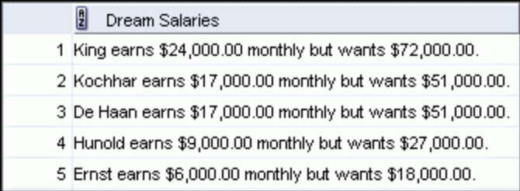

select last_name || ' earns' || to_char(salary, '$99,999.99') || ' monthly but wants' || to_char(salary * 3, '$99,999.99') "Dream Salaries" from employees;

#6 On what day of the week and date did Global Fast Foods’ promotional code 110 Valentine’s Special begin? Display all columns.

Tuesday.
select to_char(start_date, 'Day') from f_promotional_menus where code = 110;

#7 Display each employee’s last name, hire date, and salary review date, which is the first Monday
after six months of service. Label the column REVIEW.
Format the dates to appear in the format similar to Monday, the Thirty-First of July, 2000
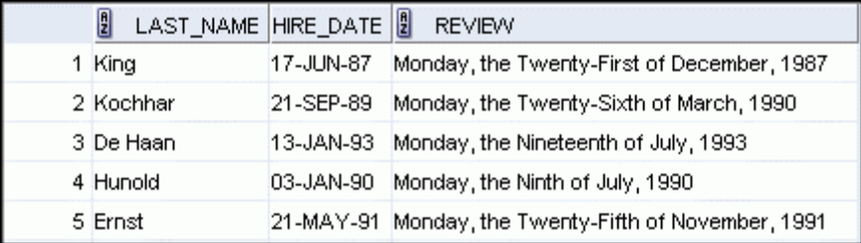

select last_name, hire_date, to_char(next_day(add_months(hire_date, 6), 'Monday'), 'fmDay, "the" Ddspth "of" Month, yyyy') REVIEW from employees;

#8 Create a query that will format the DJ on Demand d_packages columns, low-range and high-range package costs, in the format $2500.00. Display all columns.

select code, to_char(low_range, '$99999.99') LOW_RANGE, to_char(high_range, '$99999.99') HIGH_RANGE from d_packages;

#9 Create a report that shows the Global Fast Foods promotional name, start date and end date from the f_promotional_menus table. If there is an end date, temporarily replace it with “end in two weeks.” If there is no end date, replace it with today’s date.

select name, start_date, nvl2(end_date, 'end in two weeks', sysdate) from f_promotional_menus;

#10 Not all Employees receive a commission Instead of displaying a null value for these employees, replace null with zero. (NVL)

Display: Employee’s last name and commission, new field showing NULL commissions with a 0 instead of a NULL.

select last_name, commission_pct, nvl(commission_pct, 0) from employees;

#11 The manager of Global Fast Foods has decided to give all staff that currently do not earn overtime an overtime rate of $15.00. Construct a query that displays last names and overtime rate shown as $15.00.

select last_name, to_char(nvl(overtime_rate, 15), '$99.99') from f_staffs;

#12 Create a query that displays the employees’ last names and commission amounts. If an employee
does not earn commission, show “No Commission.” Label the column COMM.

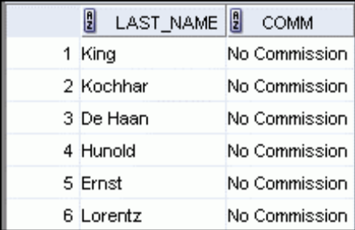

select last_name, nvl(to_char(commission_pct), 'No Commission') COMM from employees;

#13 For all null values in the specialty column in the DJs on Demand d_partners table, substitute “No Specialty.” Show the first name and specialty columns only.

select first_name, nvl(specialty, 'No Specialty') from d_partners;

#14 Display the last name, hire date, and day of the week on which the employee started. Label the
column DAY. Order the results by the day of the week, starting with Monday.

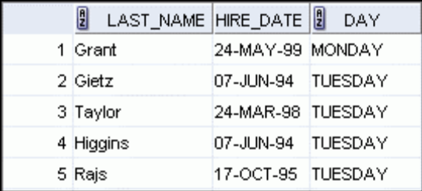

select last_name, hire_date, to_char(hire_date, 'Day') DAY from employees order by to_char(hire_date, 'd');
--I couldn’t figure out how to sort starting from Monday (d = 1). Only “order by” info available is for ascending and descending.

#15 Use the Oracle database employees table and CASE expression to decode the department id. Display the department id, last name, salary and a column called “New Salary” whose value is based on the following conditions:

If the department id is 10 then 1.25 * salary
If the department id is 30 then 1.5 * salary
If the department id is 60 then 1.75 * salary
Otherwise, display the old salary.

select department_id, last_name, salary,
case department_id
when 10 then 1.25 * salary
when 30 then 1.5 * salary
when 60 then 1.75 * salary
else salary
end "New Salary"
from employees;

Use Coalesce Function.

#16 Display the first name, last name, manager ID, and commission percentage of all employees in departments 80 and 90. Display the manager ID in an additional column called “Review.” If they don’t have a manager, display the commission percentage. If they don’t have a commission, display 99999.

select first_name, last_name, manager_id, commission_pct, coalesce(manager_id, commission_pct, 99999) review from employees where department_id = 80 or department_id = 90;

